**26 Carboxylic acids – derivatives and further reactions**

**Topic summary**

**•**  The acid strength of **carboxylic acids**, RCO2H, depends on their structures. In particular, electron-withdrawing chlorine atoms on the alkyl chain near to the CO2H group increase its acid strength.

**•**  Methanoic and ethanedoic acids can be oxidised further to CO2.

**•**  **Acyl chlorides** are useful intermediates, forming **esters** with alcohols or phenols, and **amides** with amines.

**•**  Acyl chlorides are much more easily hydrolysed than chloroalkanes.

**•**  **Polyesters** are formed by the condensation of a diol with either a dicarboxylic acid or a diacyl chloride.

**Key reactions you should know**

**•**  Acyl chlorides:

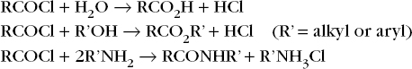

**•**  Condensation polymerisation:

http://reader.dynamic-learning.co.uk/epub_content/9781471840494/OEBPS/images/ts_26-2.jpg